**Install Active TCl**

<https://www.activestate.com/products/tcl/>

You will need to set up an account (free) and then follow the installation instructions. I installed my version here.

C:\ActiveTcl

**Install gnuplot**

<https://sourceforge.net/projects/gnuplot/files/gnuplot/>

click download latest version (executable)

I put it here

C:\Program Files\gnuplot

Next using file explorer find the file and run the executable to extract and install GNU plot.

**Configure windows**

Now you will need to add TCL and gnuplot to your path directory so that you can run these from anywhere.

To do this go to the windows search and type in “edit the system environment variables” and click on this to open the following window.

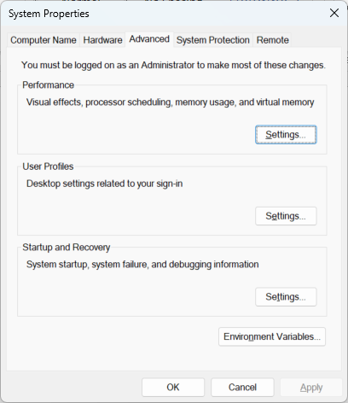

In the top window select path and click edit

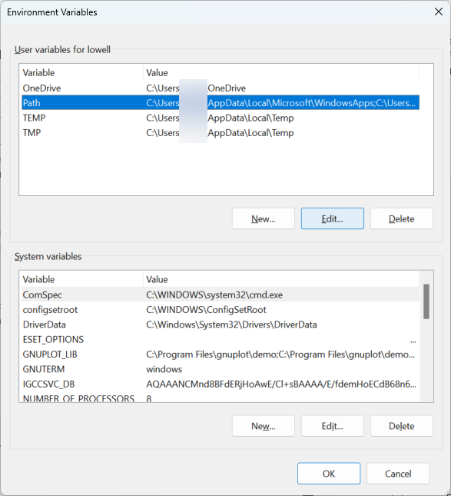

In the edit environment variable window (below), select “New” and then “Browse” and then navigate to the folder you 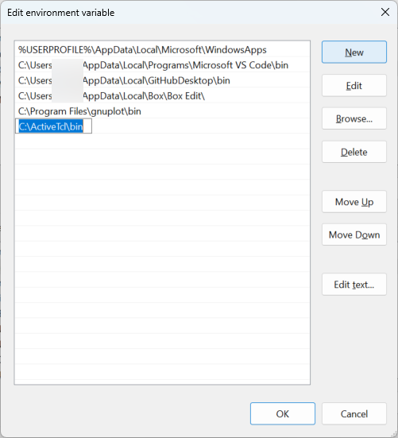want in the Path. In the example above I am adding “C:\ActiveTcl\bin”

Click “OK”

**To run the script**

* Open the command prompt (as administrator)
* Navigate to the directory with your EVPSC output files for example   
   cd C:\Users\XXXXX\Documents\Research\EVPSC\Run01
* To run the parse program type in  
   wish ../parseEVPSC_Win11.tcl MgO_3planes.dif 1